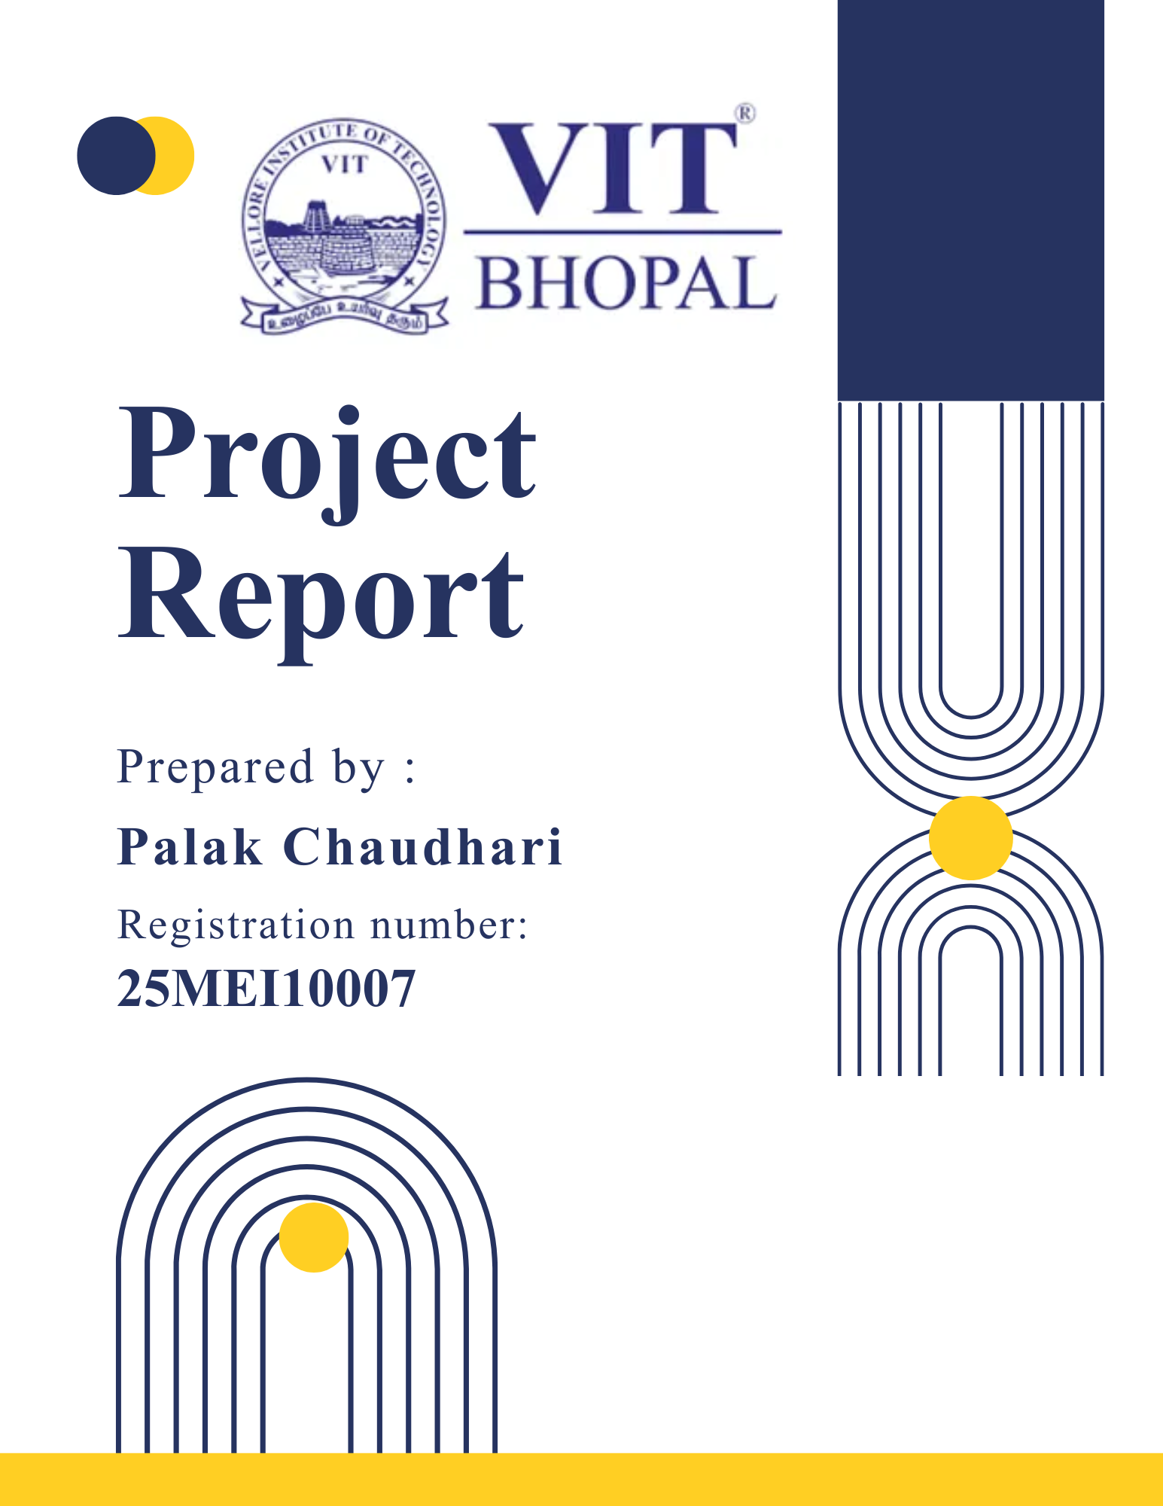

Digital Literacy Portfolio
Course: CSE0001 – Digital Literacy
Name: Palak Chaudhari
Program: B.Tech (First Year)
University: VIT Bhopal University

Introduction
We are living in a digital world where technology is playing an important role in our day-to-day life. From communication to education and financial transactions, everything is becoming digital. Keeping this in view, it is very important for students to have basic knowledge and awareness about digital literacy.
Digital literacy is not only about having knowledge of devices but also about how to use them in a safe and responsible manner.
This project has been assigned to me to get practical knowledge about different aspects of digital literacy. I have completed different tasks on awareness, communication, online platforms, and cyber safety as a Student Digital Ambassador.

Task 1: Digital Literacy Awareness
For this task, I created an infographic using Canva. The infographic included five significant topics: password security, internet usage, email etiquette, social media awareness, and cybercrime awareness.
While creating this infographic, I kept in mind that it is essential to maintain simplicity in presenting information. This task was helpful in learning how to present information in an infographic rather than explaining it in detail. This task increased my awareness of online usage.

Task 2: Student Digital Portfolio
For this task, I created my profiles on GitHub, LinkedIn, and Kaggle platforms. I was somewhat familiar with LinkedIn because I already had some connections there. However, I was not updating my profile properly before this task.

GitHub was completely new to me. I learned how to maintain my profile’s README. I found Kaggle interesting too; it is going to help me in my future learning process. This task increased my understanding of how important it is to maintain my online profile.

Task 3: Coding & Collaboration Platforms
For this task, I used HackerRank and Google Forms. I attempted a beginner-level "if-else" problem on HackerRank. I was a bit confused in the beginning, but after attempting it a few times, I got it.
I also created a Digital Literacy Quiz using Google Forms. This was quite simple. Using Google Forms, I was able to understand how data can be collected in an organized way.
This task increased my confidence in using new platforms.

Task 4: Professional Email & Etiquette
For this task, I had to write two emails: one asking for an extension of time and another asking for an internship. I also had to create a checklist of do’s and don’ts related to social media.
This task increased my awareness of how important it is to communicate in a clear and polite way. This task also increased my awareness of how our behavior on social media can influence other people.

Task 5: Cybercrime Awareness

In this task, I learned about social media account hacking. I used this as a case study and learned how people fall into traps and share their login information unknowingly by clicking suspicious links.

I also created a checklist to help me avoid cybercrimes and stay safe online. I am more aware now about online threats and how to be cautious while using social media and other online tools.

Overall Learning
Through this project, I have learned how to use different digital tools and platforms in a better manner. Also, the importance of online safety and how to be careful while using the internet was understood.
It helped me to improve my communication skills, especially while writing emails and how to present information in a better manner. Also, the risks of cyber crimes and how small mistakes can lead to problems were understood.

Overall, this project was simple but useful, and it helped me understand the topic of digital literacy in a better manner.

Conclusion

I think this project has been helpful for improving my digital skills and digital literacy. I have learned to use different social media platforms and communicate professionally. I have also learned to stay safe online and how to avoid online threats. I think this project is simple and helpful for learning about online threats and how to deal with them in real-life situations.

References
- Canva – Used for creating the infographic
- GitHub – Used for portfolio and repository creation
- LinkedIn – Used for professional profile
- Kaggle – Used for learning and profile creation
- HackerRank – Used for coding practice
- Google Forms – Used for creating digital quiz
- National Cyber Crime Reporting Portal – For cybercrime awareness and reporting information

